Frame lock error 9 on Diagnostics
Most likely modules: L (beebmaster reported similar error), G or D
Signals into drive processor R – FRLOCK (Frame lock at +5Vs), HMANCH (horizontal sync negative pulses), VMANCH (vertical sync negative pulses), CL-VID (Clipped video 0V/+12V)
Signals into G – REFH (Horizontal reference positive pulses), FI (field identification)
Signals G to H – DEM-BK (demodulator burst key positive pulses), DO-INH (drop-out protection inhibit +12V = active), CV-DOC (CVBS drop-out corrected)

Testing output from module G (Genlock)
Test: NFR25 resistor fuse 3056 for 15 ohms resistance
Result: 14.6 Ohms
Test: 1G1 8V P-P square wave with 40ms period
Result: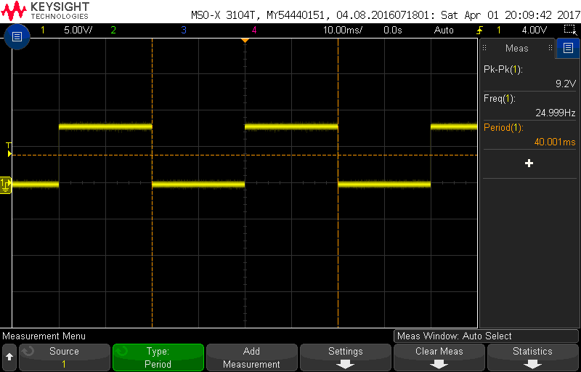
Test: 2G1 REFH 8V P-P square wave 64us period
Result:
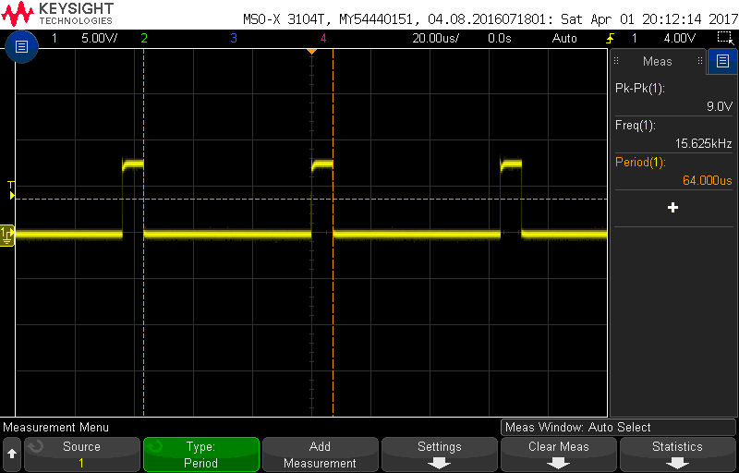
Test: Pin 6 and 7 of IC 7206-2A – 12V P-P 64us period, positive on pin 6, inverted on pin 7
Result: Pin 6 at stable 0V, pin 7 at 11.15V no activity with or without disc – FAIL (no LPO or LPO’ output from module G)
Test: 3G2 CV-DOC, 2.8V P-P burst for 64us with DC offset of 6V (video signal?)
Result: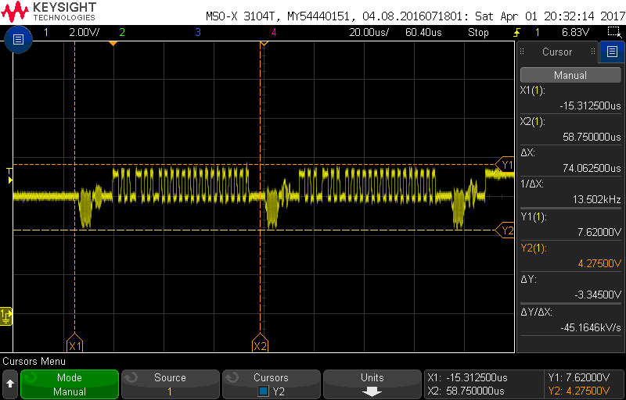
Test: 6G1 0.22uS ramp-up pulse 4V P-P from 0V offset (GL-CL) and E pin of 7014 (GLC)
Result: 6G1
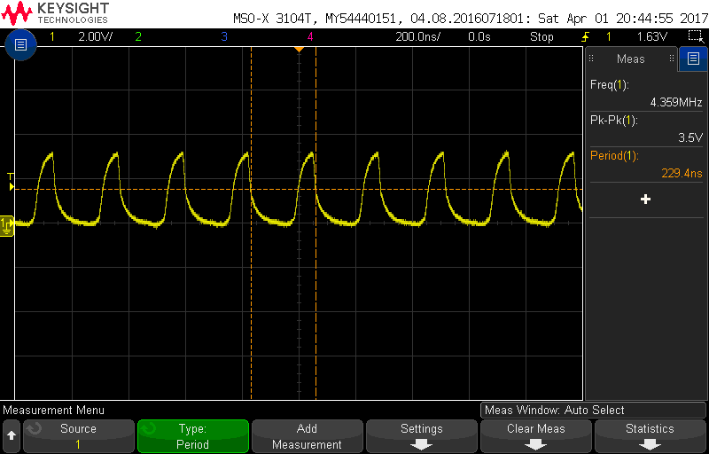
Result: E of 7014
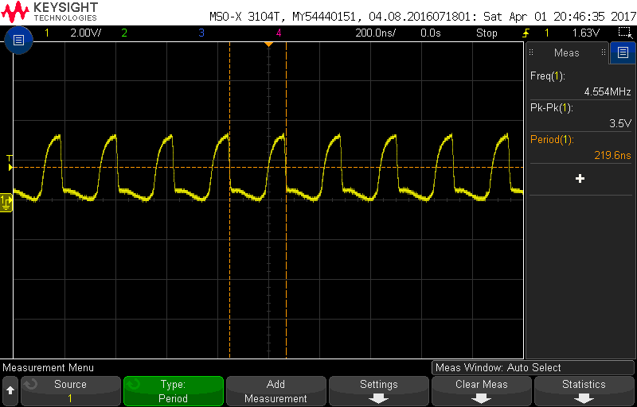
Test: 8G1 MCO output from G 4V P-P 64us stuttering square wave
Result:
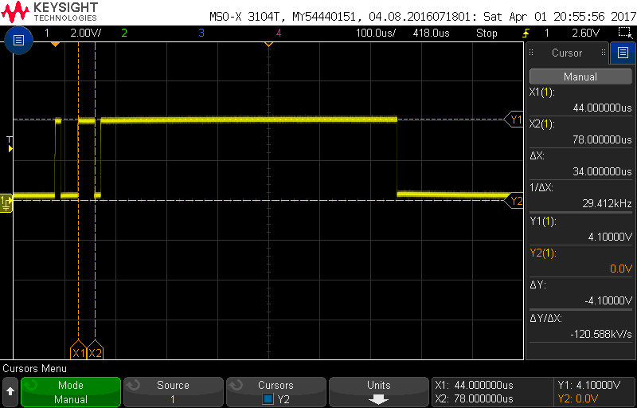
Test: 6G2 – DO-INH, 12V P-P 20ms (pin 10 of 7207)
Result:
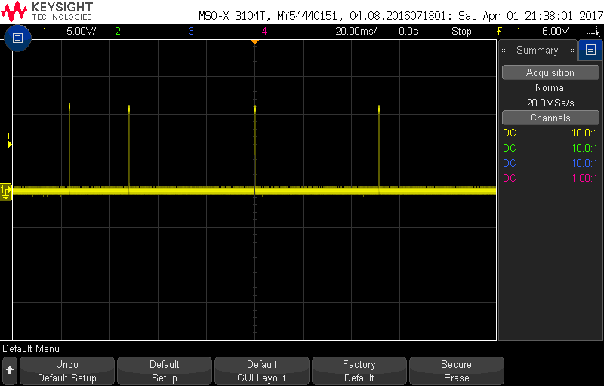
Test:
5V on 3051 OK
12V on 3001 FAIL 6R8
12V on 3004 4R7
12V on 3081 OK
12V on 3056 OK
-12V on 3002 OK

